**2-day prep before Interviews……. Ahhhhhhhhh**

-By Khushboo Goel

**TOPICSSS**

**Join this telegram channel,**

**I am sharing Internship openings**

**https://t.me/khushboogoel**

**It’s DAY 1**

1. Time Complexity revision

* <https://www.interviewbit.com/courses/programming/topics/time-complexity/>
* <https://www.geeksforgeeks.org/algorithms-gq/analysis-of-algorithms-gq/>
* Revision- <https://medium.com/@manishsundriyal/overview-time-space-complexity-f973513b701e>

1. Sorting Searching Revision!!!

* 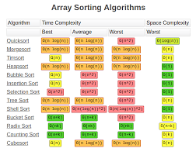
* Just read basics about alllll
* <https://www.geeksforgeeks.org/sorting-algorithms/>
* <https://www.geeksforgeeks.org/know-sorting-algorithm-set-1-sorting-weapons-used-programming-languages/>

(Must read article)

1. DS Revisionnnnn….

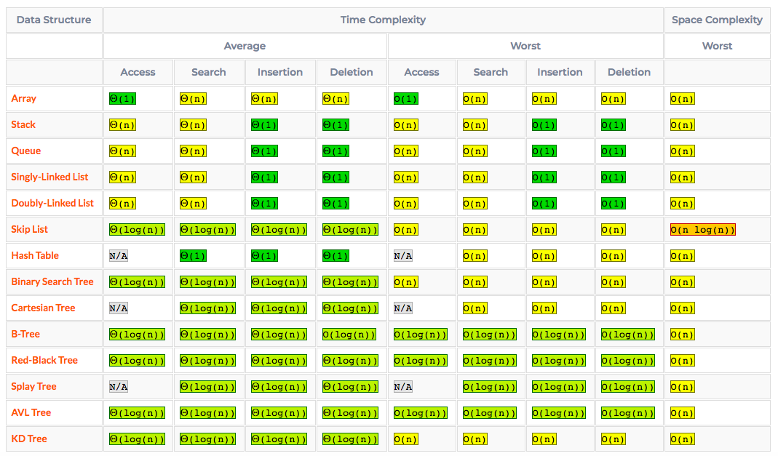

* <https://docs.python.org/3.11/tutorial/datastructures.html>
* <https://www.tutorialspoint.com/data_structures_algorithms/index.htm>

1. Binary trees……..

* Orders ...pre,post,in
* <https://www.interviewbit.com/courses/programming/topics/tree-data-structure/>
* <https://leetcode.com/problemset/all/?topicSlugs=binary-tree>

1. Hashing & Hashmaps

* <https://www.interviewbit.com/courses/programming/topics/hashing/>
* How to implement a hash??
* Coliisionss
* <https://www.youtube.com/watch?v=h2d9b_nEzoA>
* <https://www.youtube.com/watch?v=eMymKAFYaCs>

**DAY -2**

1. Stacks….&Queuesss

* <https://www.interviewbit.com/courses/programming/topics/stacks-and-queues/>
* <https://www.interviewbit.com/problems/stack-queue/>

1. Binary trees:

* <https://leetcode.com/explore/learn/card/data-structure-tree/>

1. Priority Queue:

* <https://www.interviewcake.com/concept/java/priority-queue>
* <https://www.interviewbit.com/problems/priority_queue/>

1. Graphs

* <https://www.interviewcake.com/concept/java/graph>
* <https://www.interviewbit.com/courses/programming/topics/graph-data-structure-algorithms/>
* <https://www.interviewbit.com/problems/maps-cpp/>
* <https://runestone.academy/runestone/books/published/pythonds/Graphs/toctree.html>
* <https://towardsdatascience.com/graph-data-structure-cheat-sheet-for-coding-interviews-a38aadf8aa87>

Day - 3

* Time complexity of recursion:
* <https://en.wikipedia.org/wiki/Master_theorem_(analysis_of_algorithms)#Case_1_example>
* <https://www.geeksforgeeks.org/convert-normal-bst-balanced-bst/>